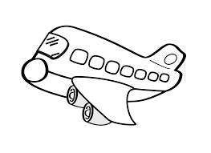
Books on Flight Response Questions
Please write ALL the facts you already knew about flight:

Please list 3 books you read from the “Books on Flight” collection. Include Title and Author(s).
1)___________________________________________________________
2)___________________________________________________________
3)___________________________________________________________
What 3 new questions do you have after reading books about flight?
1)___________________________________________________________
2)___________________________________________________________
3)___________________________________________________________
How/where can you find answers to these questions?

Please list and describe 3 important facts you have learned from reading books on flight that you believe your classmates should know!
1)_____________________________________________________________________________________________________________________________________________________________________________________
2)_____________________________________________________________________________________________________________________________________________________________________________________
3)_____________________________________________________________________________________________________________________________________________________________________________________
Please draw and label a picture explaining 1 important fact from your list above.

Extra writing room.

