Creative Writing Prompt 1-300
Monday, April 20th.
Sometimes it can be difficult to start writing.
First, choose a number between 1-300.
Send Ms. Kostiniuk your chosen number by email.
You will receive a writing prompt from Ms. Kostiniuk. It will be your special writing prompt because what are the chances you pick the same number as someone else!
With your prompt, your challenge is to be AS CREATIVE AS POSSIBLE!
Read the prompt, brainstorm ways that you can express your thoughts. You do not need to respond in a typical paragraph form. Brainstorm different possible ideas to include in your writing is a good place to start. Then begin, however you want.
THE RULES:
-You must complete the prompt provided
-It must cover at least three quarters of a page
-Edit and revise your prompt.
Share it with a family member.
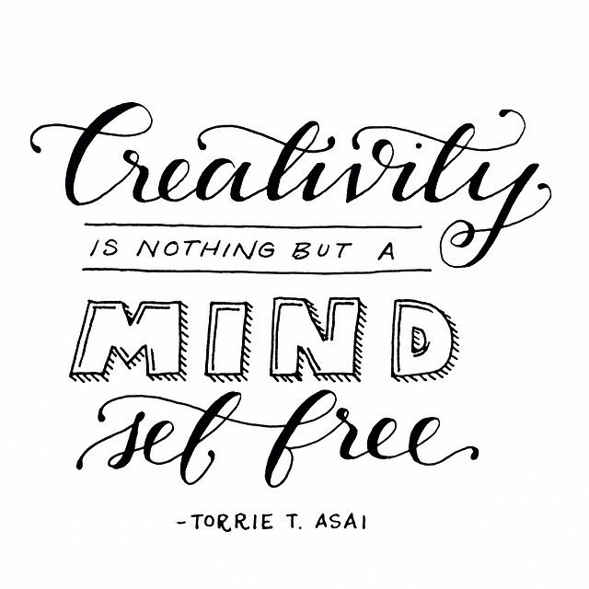
Finally, you will be sharing your prompt with your classmates.
*Email Ms. Kostiniuk with any questions.

