Airplane Design Project

For the final project in our Flight unit, you are going to design and build a model airplane using recycled materials. You will need to design, test, and modify your airplane to make it fly as far and straight as possible.

When you are designing your airplane, you need to keep in mind the concepts we have learned about flight:

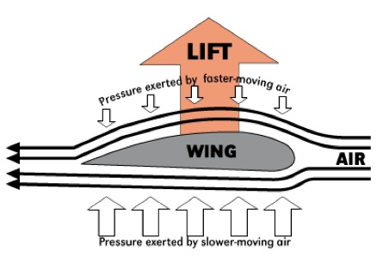
- The best wing shape that allows for the most lift. When building, attempt to create the best design to produce lift and keep your plane flying for as long as possible.
Bernoulli’s Principle applied to an airplane wing:
- Airplanes are aerodynamic. This means the plane can move easily through the air. Try to design a plane as aerodynamic as possible.

- Your model airplane should have the same parts as a real airplane. You must include the following: fuselage, wings, vertical stabilizer, and horizontal stabilizer.

- You may also choose to include some more parts of the plane that help control flight such as: ailerons, flaps, rudder, elevators, etc.

- Make sure to follow the design process! The design process is included in this document.

Design Process
Follow the design process when planning your model airplane.
Planning your airplane design will be done first. Draw out all your ideas for each part of the plane and include what you will use to build it.

- Create a list of materials you will need for building. For example, you may require construction paper, scissors, glue, tape, straws, string, Styrofoam, plastic bottles, Kleenex boxes, toilet paper rolls, cereal boxes, cans, bubble wrap, paper clips or pencils.
Ideally, you are trying to come up with a design that flies, and this may need some critical thinking. Search around your house for ideas.

- For each box below, draw a sketch of each airplane part. Include estimated measurements (size) of each material required. Include the material each part will be made from.
- Finally, draw a sketch of all your materials assembled to complete your model plane design.
Possible Materials Needed:

Design Sketches

Fuselage | Wings
Horizontal Stabilizers | Vertical Stabilizers
Entire Airplane: All the materials combined to create the whole airplane. Include side and top view if possible.

Build, Test and Modify your Airplane

Build
Build your airplane following your design drawings. You can make changes from your original design if needed. Make sure to ask for parent/guardian help when working with sharp tools. Take pictures of yourself building and assembling your airplanes if you can.
Test & Modify
After building your plane, it is time to test it out. You will need to identify a starting point for throwing your plane and keep in mind the space to throw and land should be an open area.
You will need a tape measure to record the distance your plane flies. Please complete at least 3 test flights, recording the distance for each attempt. Once you finish a test flight, fill in the chart below.
* If you could video a flight run, that would be excellent for submitting your project.

Test Number | Flight Distance | Problems with flight | What I will change
1
2
3

Make the necessary changes to your airplane in attempt to fix any problems with flight. Retest your plane and fill in the chart below. You can continue to modify and test your plane by creating a chart like this one on a separate piece of paper.

Test Number | Flight Distance | Problems with flight | What I will change
1
2
3

When you have a plane you are happy with (one that has the best flight run), take a picture of you holding your model airplane and submit it along with the distance it flew, (video and pictures if possible), and your design process booklet!

CONGRATULATIONS!
YOU HAVE FINISHED THE AIRPLANE DESIGN PROJECT
AND COMPLETED OUR FLIGHT UNIT!

